**SQL Hands-on**

**Steps:**

Open MYSQL..

Password:Viciwaran@2412

**Creating Database**

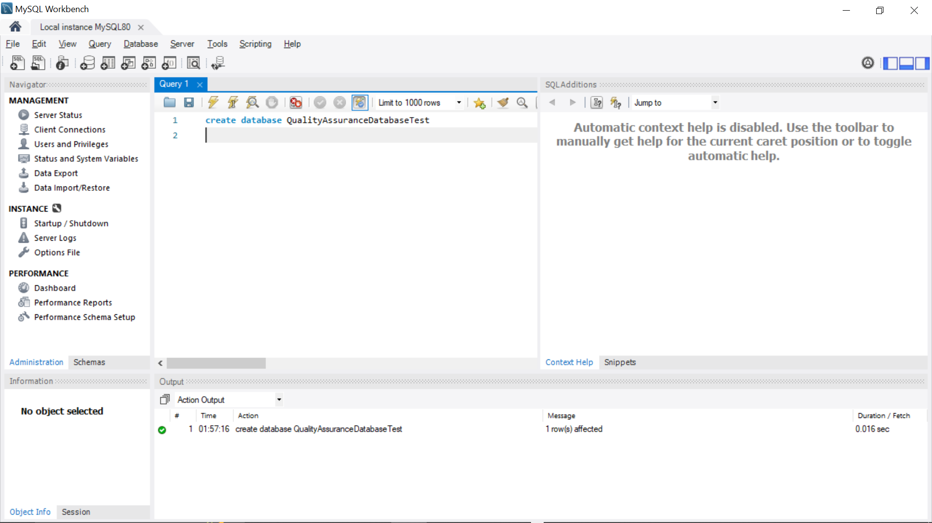

**Created Table and Describing employee information**

**Adding values into the table**

**Printing the entire table**

**Usage of Distinct:**

**It avoids duplication of data.**

**Usage of where(to give condition)**

**Usage of And(more than one condition)**

**Usage of OR(for condition with choice)**

**Usage of “in”**

**Usage of Between**

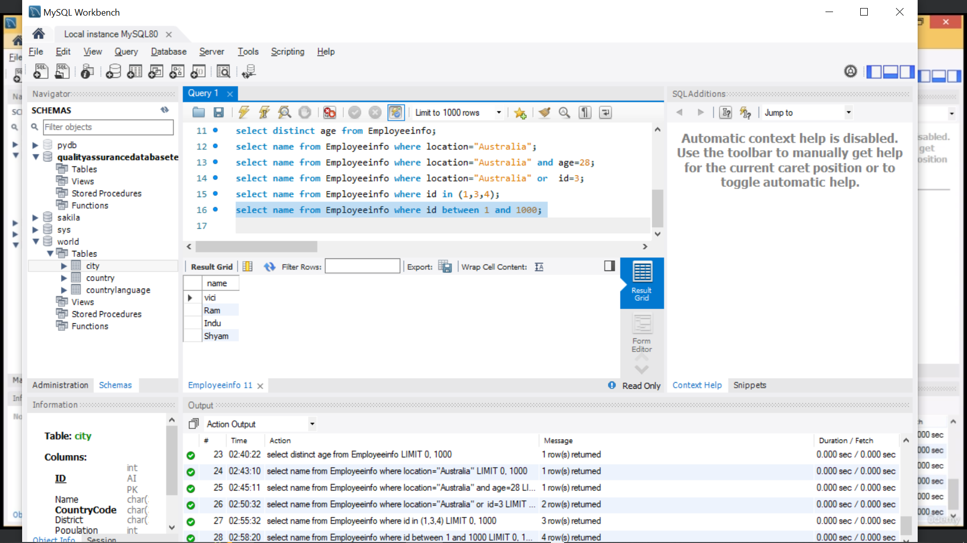

**Usage of % and _**

**A% - first letter A**

**_A%- second letter A**

**__A= only 3 letter and 3rd letter is A**

